


METHODOLOGY OF IMPLEMENTATION OF TECHNOLOGY VETIVER (VS) FOR THE ABSORPTION OF NITROGEN AND WATER IN IRRIGATED LANDWITH WASTEWATER FROM THE PIG INDUSTRY.

OCTOBER 2010

PROPOSAL FOR THE VALIDATION OF THE TECHNOLOGY VETIVER

This proposal, originated as a result of the requirement of swine production agribusiness in designing and implementing a trial leading to the validation of new technologies that minimize environmental impacts associated with pig production.
The Instituto de Investigaciones Agropecuarias (INIA Quilamapu) has been integrated to this project as a validator agent of the technology and gives a constant advice to this important challenge.
EcoGroup Ltda. It is responsible for the implementation of the validation project, which involves the production of nursery plants vetiver Lomas de putagas, Linares (SAG Registration V/FO/0/7 - 1339), planting design, consulting crop, measuring parameters, management and information processing.

1 .- OBJECTIVES
The purpose of the proposal is to determine the usefulness of vetiver as a viable technology system for the absorption of water and nitrogen in the soil irrigated with effluent obtained from the manure treatment process along with other applications.
1.1 OBJECTIVE 1: Determine the production of vetiver, to the soil and irrigation conditions prevailing in the place, through objective measures of development.
1.2 OBJECTIVE 2: Determine the amount of nitrogen absorbed by Vetiver, in a given period from planting.

2.-DEVELOPMENT PROJECT
2.1 .- EXECUTION OF TEST
According to the plan submitted for the implementation of this project was dated 01/16/2010 planting of 2,040 meters of vetiver (Chrysopogon zizanioides var sunshine) in the form of different treatments:
T1 = Vetiver + Effluent

T2 = No Vetiver + Effluent
Vetiver + T3 = Vetiver + Irrigation Water
Vetiver + T4 = No Vetiver + Irrigation Water

No. 1 Fig 1 IMPLEMENTATION OF EFFLUENT TREATMENT WITH FLOW MEASUREMENT

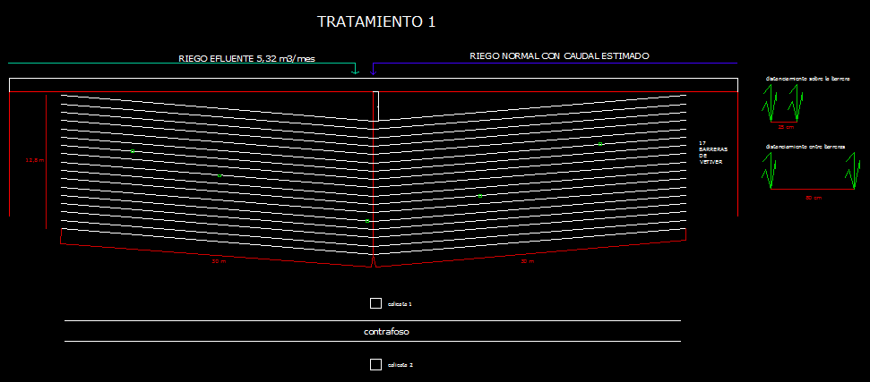

Fig N ° 2 TREATMENT 3 IMPLEMENTATION OF IRRIGATION WATER FLOW MEASUREMENT

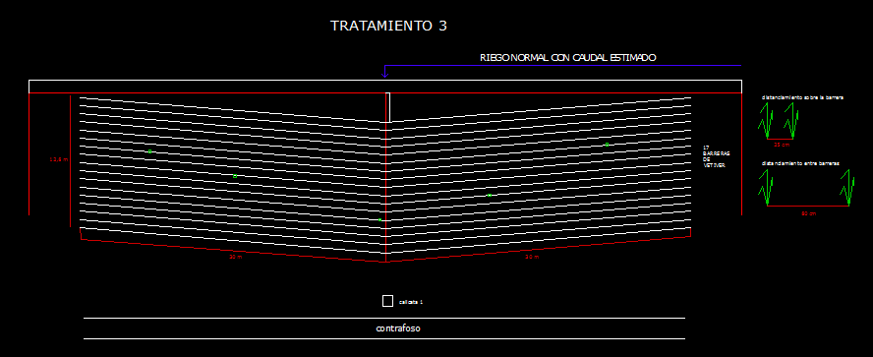

As shown in Figure No. 1 and No. 2, about 8,160 vetiver plants were planting with distances of 0.8 m between rows and 0.25 m on the line. The proposed design involves a 5% retention angle. This is done to allow better performance of the barriers of vetiver as a biofilter and retain greater amounts of sediment.

The planting of vetiver for T1, occupied a total of approximately 4,080 plants. Same amount spent in T3, so you can compare the performance of both tests.

Photo 1: Planting rooted vetiver do T1 mode (bare root)

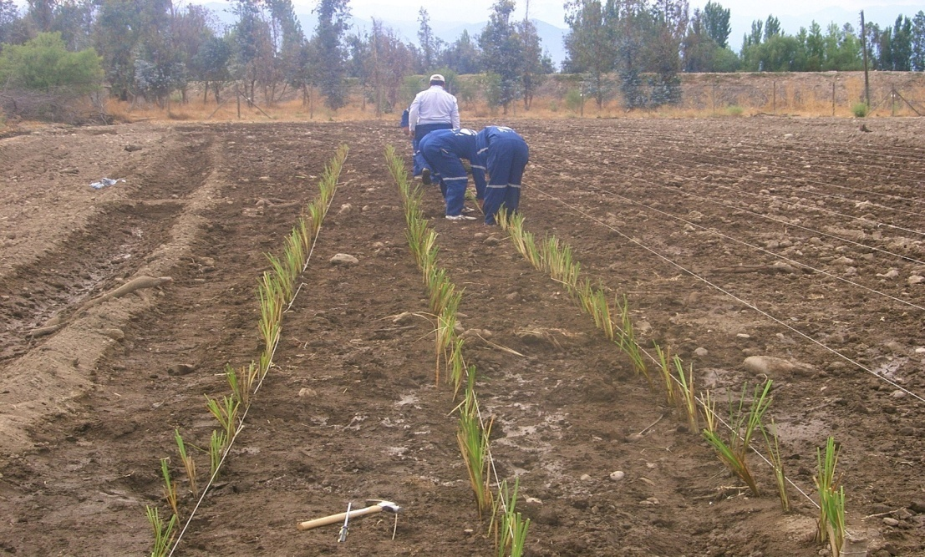
January, 2010
Photo 2: Planting vetiver T3, you rooted mode (bare root)
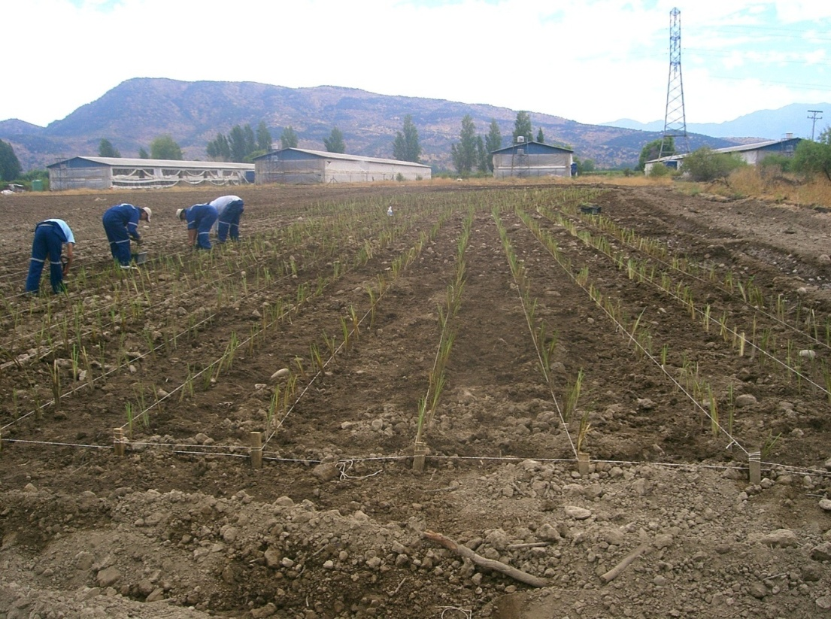
January, 2010
Immediately after planting was identified by signs, of the different treatments to facilitate further analysis of soil, leaf and risks involving the performance of the test.

2.2 HYDRAULIC STUDY.
For the correct application of the different treatments is essential to define the amount of irrigation water and effluent to be applied in different fields of study. Because vetiver is planted in the form of pre-rooted cuttings or nursery beams and bare root, you should not neglect the necessary irrigation water to allow growth and development of the species.

According to data recorded by the researcher Paul Truong, in relation to nitrogen uptake by vetiver plant in Australia, was established as a supposed maximum absorption of 1,200 kg N / ha per year. For the same density of plants employed in this trial (5 pl/m2).

Due to the high concentration of nitrogen in the effluent, it must cause dilution to irrigate the whole area proposal, so that the plants receive sufficient moisture for growth and development.

Based on the concepts outlined above and know details such as soil depth, potential evapotranspiration, Kc crop, soil bulk density and flow of effluent to be used, made the following table to define the flow of irrigation required for T1 and T3

Table No. 1 Hydraulic design of vetiver irrigation T1
Source: Developed for this study
Irrigation was started to perform on a daily basis dealing with effluent Lt 213 for T1 and T2. It began with the daily records of flow applied.

2.3 SAMPLING AND RECORDS
2.3.1 ANALYSIS OF SOIL
At the time of departure of this test was conducted soil sampling in the different strata through the conduct of trial pits. This sampling was carried out by INIA-Quilamapu staff.

1 trial pit was performed for each treatment plot, within which 5 were sampled soil layers that are plotted below:

Chart 1: Comparison of the concentration of N in the soil of different treatments

Source: Compiled from data provided by Laboratorio de suelo- INIA Quilamapu.
Note that the soil analysis carried out also considers other parameters of agronomic importance for discussion. These records are not shown in this paper due to the magnitude of the information.

2.3.2 LEAF SAMPLING

Another activity was the sample leaf cut from the leaves of vetiver, the time of planting and once a month to measure the concentration in the leaf of the different elements.This activity allows you to compare the evolution of the concentration of different elements in the leaves of vetiver to correlate with the growth and biomass production. As vetiver grows and produces leaves, are extracting elements from the soil.
The results, after 6 months of the trial, are plotted below:
Graph 2: foliar concentration of different elements in T1

Source: Results from leaf samples provided by INIA Quilamapu.
Chart 3: leaf concentration of different elements in T3
Source: Results from leaf samples provided by INIA Quilamapu.
For the treatment situation 3 we see the same trend of increased concentration for treatment 1. However, it is noteworthy that leaf nitrogen concentrations are generally lower than T1, which corresponds to the vetiver plot irrigated with effluent.
2.3.3 EFFLUENT SAMPLING
Another important record corresponds to the sample concentration of elements present in the lagoon effluent is irrigated by which in diluted form T1 and T2.
This record was in charge of a specialized laboratory and the results until now are:

Table No. 2

Source: Record submitted by laboratory
The effluent sampling is performed at intervals of 15 days to extrapolate the results in those days not sampled. These results are correlated with the volume of effluent applied to measure the amount of nitrogen added to the plots of T1 and T2
2.3.4 MEASUREMENT OF GROWTH AND DEVELOPMENT OF VETIVER
To learn about the extent of growth of vetiver species in the different treatment plots, it was nade a measuring of height and tillering of 1% of total plants often than 1 time per month.
The results to date on growth and tillering are plotted below:

Chart 4: Measurement of vetiver plant height

Source: Compiled from averages recorded over 1% of total plant

Tillering in vetiver is a measure of development, as each outbreak plays a key role in closing the barrier that allows the functionality of biofilter.

Thus vetiver surface sediments can trap and filter contaminants from soil and water.
Chart 5: Measurement of vetiver plant tillering

Source: Compiled from averages recorded over 1% of total plant
3 .- PRELIMINARY RESULTS

3.1 Grow and development of vetiver.
As for height measurement, vetiver has stabilized at 50 to 60 cm approx., Obtaining a greater degree of growth T1, which corresponds to the test with effluent irrigation.
Tillering of the plant behaved exponentially until April, at which stabilizes due to the entry into winter break.it is noted taht T1 gets greater tillering than T3.
Notably, the amount of fresh material for each cut leaf analysis decreases progressively as one moves to the winter months.

For those cuts will be measured in the harvested area, which compares with biomass production and laboratory analysis.
Photo 3: Cultivation of vetiver after two months of establishment
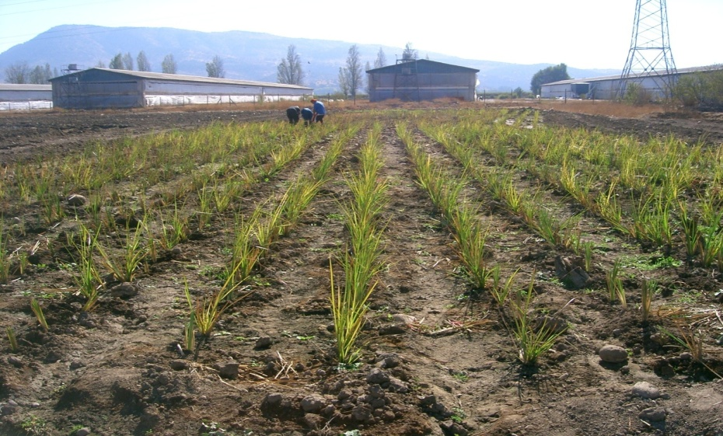
March 2010
When making comparisons between T1 and T3, on leaf N concentration in vetiver, we see that T1 has higher concentrations of N T3 for almost all months except April.This feature may indicate that irrigation with effluent permit greater leaf N concentration of vetiver.

At the time of establishment, vetiver has a concentration of 0.59% N leaf. This figure increases as the crop establish itself as the plant begins to adapt to changing ground conditions.After 6 months of development can be estimated close to 2% concentration of nitrogen. This figure is important when making the calculation for extracting the item.

3.2 Elements Contributions to T1 and T2
According to records and data obtained from testing, it is important to perform the respective analysis of the contribution of nitrogen and other elements of the system and behavior of vetiver to soil and water situation characterized.
The following table shows the summary analysis of the contribution of nitrogen, phosphorus and potassium, with the respective calculation of nitrogen accumulation in soil structure, according to data submitted by the laboratory.

Table No. 3 Summary of the contribution of N, P, K for T1 and T2

Source: Compiled from data submitted by the laboratory and History of Irrigation.
According to the accumulation of evidence submitted to the treatment plots, the total nitrogen contributed untill 13/06/2010 is up to 32.17 kg equivalent to 418.91 kgN / ha, for both T1 and T2. According to the irrigated area, the final contribution to the essay can not exceed the equivalent of 92.16 kg N / year for each of the treatments, equivalent to 1,200 kg N / ha / year.

In relation to soil tests conducted by INIA Quilamapu, is observed in the 4 treatments, a large accumulation of nitrogen, phosphorous, potassium and sulfur available in the soil. It is shown an unbalance soil with toxicity for most crops, due to the high concentration of nitrogen in the different stratas.
Despite the adversity of soil conditions, vetiver fails to grow in height and tillering at a good speed, compared with the crop in other parts of the country.

3.3 Removal of items by vetiver
According to preliminary analysis, the extraction of nitrogen for four cuts made, equivalent to 23.84 kg N / ha for treatment 1. The methodology for calculating this figure relates the sample fresh weight, dry weight and percentage of dry matter, surface sampling results in the laboratory for leaf analysis.
For treatment 3, the removal of nitrogen until now corresponds to 19.95 kgN / ha. The calculation methodology is the same made in T1, relating fresh weight, dry weight, % of dry matter, size and leaf analysis data obtained from laboratory INIA Quilamapu.
Chart N ° 6

Source: Compiled from data analysis of soil laboratory Quilamapu INIA
Chart No. 6 shows the comparison of extraction of N in treatments 1 and 3 correspond to the test with and without effluent respectively. These figures are derived from the weights of the cuts made (harvesting of vetiver) in a particular area. The treatment irrigated with effluent shows higher nitrogen removal than the treatment without effluent. The evaluation of the difference generated between the two treatments indicates the removal of N in effluent, as to the soil conditions (high concentrations of nitrogen) vetiver plant absorbs great amount of this element from the ground.

The project involves the end of a given period at least will be harvested in vetiver entire plants found in orchard previously defined, however the winter break has hindered the development of vetiver, it is necessary to conduct the evaluation after agricultural season.

4 MODEL OF BIOMASS PRODUCTION
The international literature indicates that the potential production of biomass of vetiver is 100 to 120 ton / ha / yr of dry material, which is far superior to other plants with high value in the production of biomass.

Research by Dr. Paul Truong, a senior specialist in soil conservation of the department of natural resources from Brisbane Queensland Australia, show the comparison of biomass production potential of 30 to 40 ton / ha / year of species such as Miscanthus MS , Populus sp, Eucalyptus sp and Salix sp, regarded as highly productive.

From the experience in Chile, in terms of production of vetiver in areas as Quillota V Region, Linares VII region and Lampa in metropolitan area, you can build a production model to predict crop biomass of vetiver and its corresponding extraction nitrogen in later months.
Chart No. 7 Model of Dry Matter Production of Vetiver

Source: based on existing experience in Chile by EcoGroup Ltda.

In Figure No. 7 shows the growth model of vetiver and projection for future months of development. This model considers the treatment 1 (Vetiver + effluent) with an output of about 60 t / ha / year, considering the first year of development. For the second year of development, vetiver could produce over 100 t / ha / year, as reported in several countries with climates similar to Chile.

The interesting thing about this background is that with a yield of 60 t / ha / year and 2% concentration of nitrogen in the leaves, would achieve a removal of 1,200 kg N / ha / year, which represents the estimated start of extraction test. However, should be noted that vetiver not only extracts nitrogen from the effluent, but also made from the ground. So subtract the absorption performed from the ground with effluent (T1) to produce vetiver absorption without effluent treatment (T3).

Considering the potential reported by international researchers of vetiver technology, the species could remove 2,400 kg N / ha / year, which not only help absorb nitrogen from the effluent supplied to the system, but also result in the highly saturated soil decontamination by this element.

Pablo Molina, agronomist engineer
VETIVER-CHILE
EcoGroup Ltda.

